**not selected selected**

**Tip**

The pale blue highlight indicates that the Solitaire icon is ‘selected’ which is a sign that the computer’s focus is on this.

Once it is selected just **press** the Enter key to **open** Solitaire. The Enter key is the confirm or ‘go’ key!

This does the same as **double-clicking** the mouse on the icon … only better because it always works and double clicking is often unsuccessful (as it has to be done very quickly without moving the mouse) – and this leads to impatience!

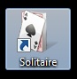

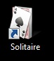



1. **Find** the Solitaire icon on your desktop.

**Click** once on the icon to select it.

Then **press** Enter to open the game (or **double click** on the icon).

1. A Solitaire window will open that does not fill the screen. **Click** on the ‘maximise’ box in the top right hand corner to fill the whole screen with the window. (It will be easier to concentrate on the game and not be distracted by the desktop.)



Maximise

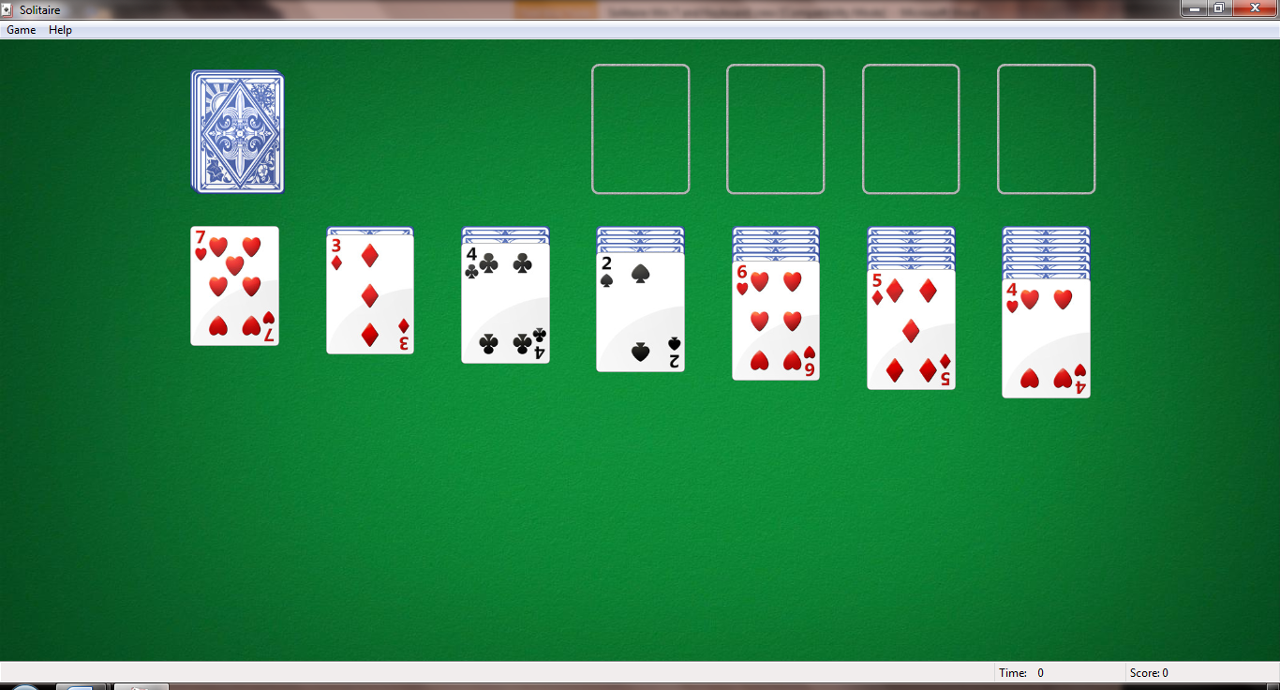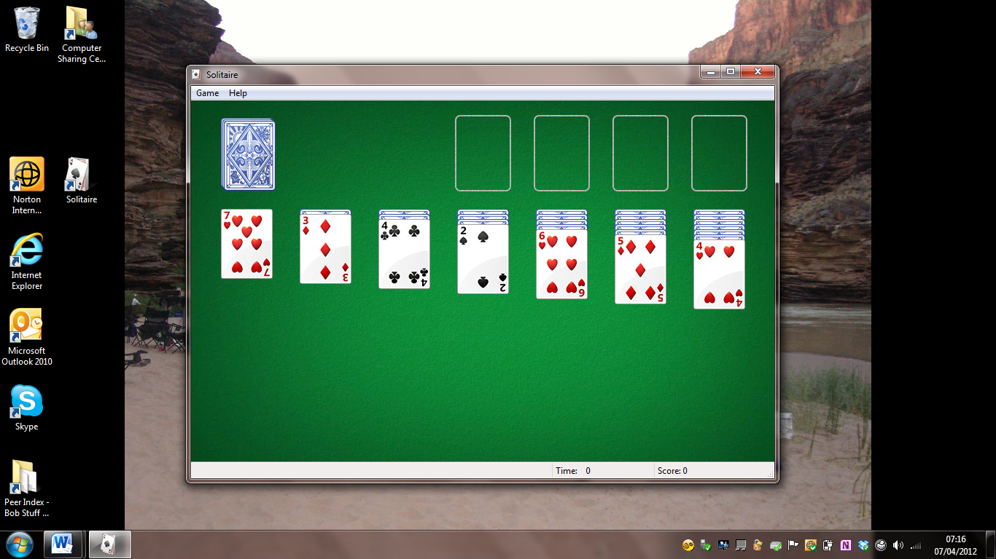



Another way to maximise a window is to **open** the ‘Window Control box’:

1. **Press and hold down** Alt (with your left hand)
2. **Press**  Spacebar (with your right hand)
3. 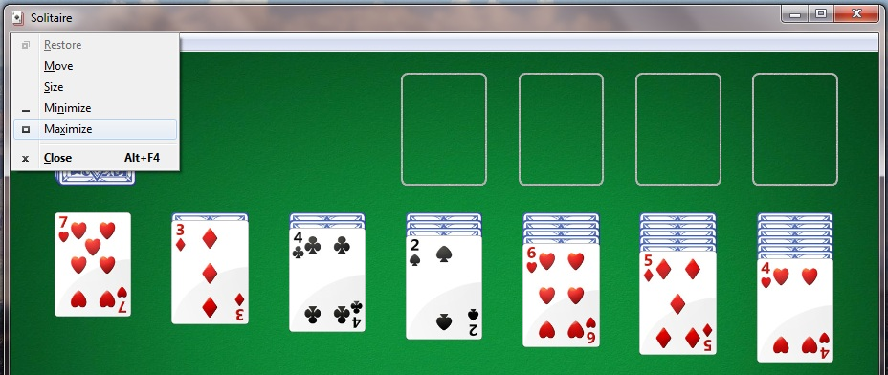Then **release both keys** to open the box shown here (this works for all windows)

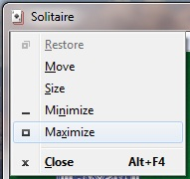To maximise the window and make it fill the screen, you can either:

1. **press**  to

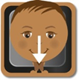

1. Or **navigate** down with the down arrow to select ‘Maximise’ then **press** Enter!
2. **Why not choose** your own deck of cards using the Menu Bar at the top of the Solitaire window? –

 



**Menu bar**



**Press **Alt to ‘wake up’ the Menu Bar so that it shows the underlined letters that will action the options. (If you just **click** on “Game” as shown above (on the Menu Bar) it will not underline the letters.)

**Press** the down arrow to **navigate** down to “Change Appearance”   
(it will become ‘selected’ with a blue border) then **press** Enterto action this option – alternatively you could just **press** the underlined letter .

The table of options also gives you the Function key (F7) that would do the same thing. (Alternatively **click** on “Game” then **click** on “Change Appearance”).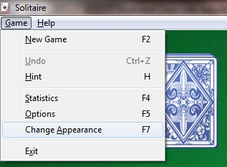

**Tip** 

Using the arrow keys to navigate through different options is the same method used with mobile phones and TV remote controls…(and a lot of new technology interfaces). It is a very good way to slow down and learn more. It also avoids dependency on the mouse and the possibility of repetitive strain injury.

1. 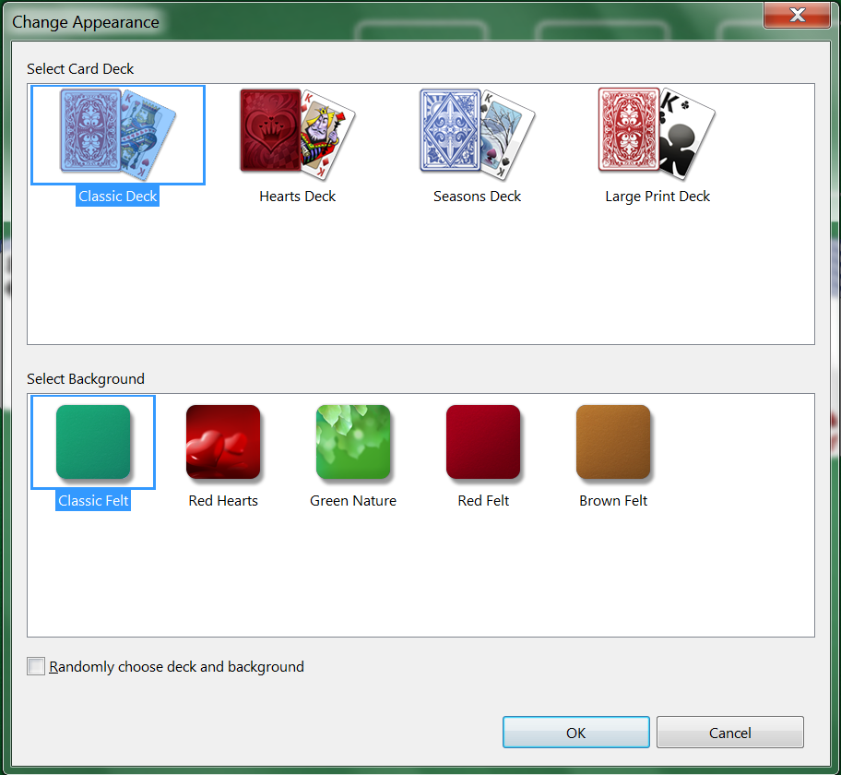The “Change Appearance” box appears where you can choose the deck of cards and background you like. **Click** on the card deck and background, or **Tab** through to the area you want then **arrow key** to your choice (*you have to watch carefully to see where the computer’s attention is! Your choices will become highlighted in blue*).



Check that the “OK” button is ‘selected’ then

 **press** Enter to ‘go’

(or **click** on the button).



1. The game is now ready to be played with this deck and background…. *this is the fun part*. By playing Solitaire your attention is on the game and not on the difficulty of using the mouse which enables you to dramatically improve your mouse skills in a short space of time.
2. 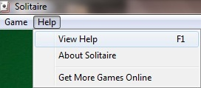If you are not sure of the rules of how to play Solitaire you will need to get “Help”. **Click** on the “Help” menu (or **press** Alt then H), **navigate** down to “View Help” (it will be ‘selected’ in blue) and **press** Enterto open it. (Alternatively **click** on “View Help” - or **press** the F1 key for help).



**Tip**

The “Solitaire” window’s ‘title bar’ is a faded grey showing that it is inactive.

The “Change Appearance” box has a brighter title bar with the close box in red showing that it is active.

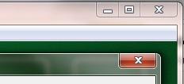

This means that the computer’s attention is on the “Change Appearance” box.



**Title bar**

This is the ‘Windows Help and Support’ window. Scroll down or arrow key down to the bottom of this page to read further. It is worth spending some time on this!

**Solitaire**

The object of Solitaire is to use all the cards in the deck to build up the four suit stacks in ascending order, beginning with the aces.

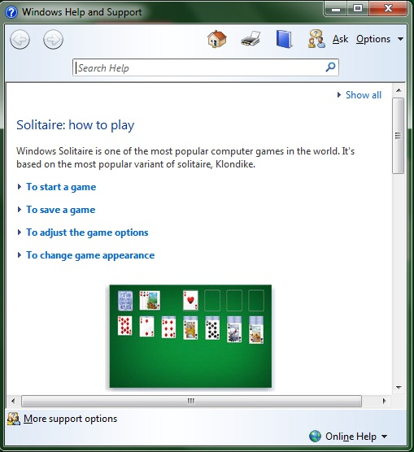

**Tip**



You could maximise this window to read the text more easily.



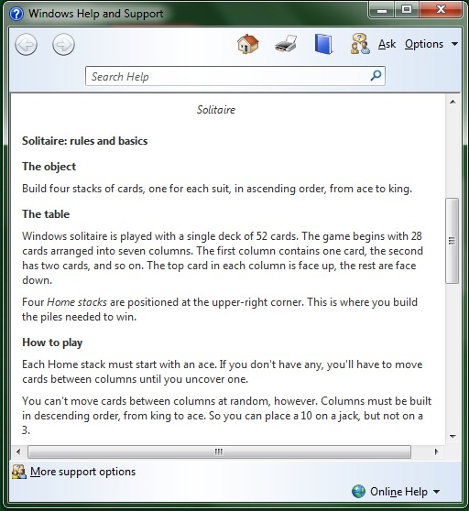

**Scroll bar**

The scroll bar shows the proportion of this whole page that you can see. Here it is about a third of the page. Use the arrow keys to move up and down, left and right, or scroll with the mouse wheel.

1. The game of Solitaire is played by arranging cards in descending order (with alternate colours) on the seven row stacks (stacks of cards in a row of 7), so that you can reveal the cards hidden underneath, and go on to successfully build up the four same suit stacks above them in ascending order, beginning with the aces.

To turn over a new card, **click** on the deck, even when they have run out! Good luck…

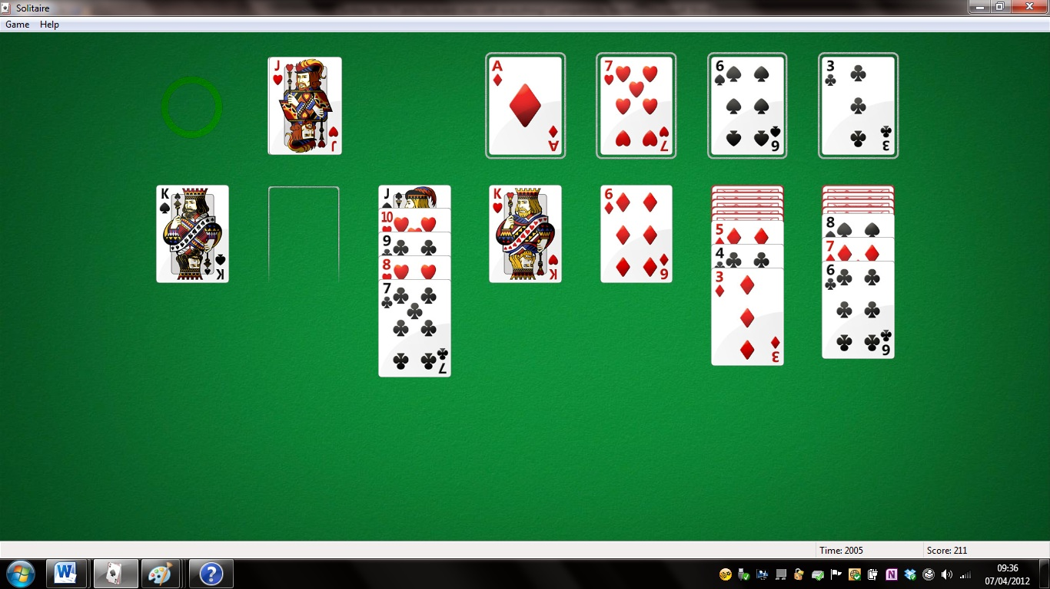



1. This is what happens when you successfully stack all the four suits from ace to king!

It is easier to win if you draw one card instead of three. You can play this game without using the mouse but you have to work it out for yourself! Good luck.

